

**Asset Practice Questions: Mathematics**

1. Look at the card pattern below.

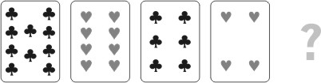

Which of the following should be the next card in this pattern?

A.  B. 

C.  D. 

2. 5 years ago, Jack was 10 years old. Jill will be 10 years old next year. Who is the older of the two and by how many years?

A. Jack is older by 6 years

B. Jill is older by 10 years

C. Jill is older by 5 years

D. Jack is older by 15 years

3. Amit is using a bigger glass and Swati is using a smaller glass to fill the water bottle.

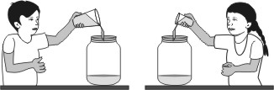

Amit fills the bottle in 5 turns. How many turns will Swati take to fill the same bottle?

A. exactly 5

B. more than 5

C. less than 5

D. She will never be able to fill the bottle with water using her glass.

4. See the number pattern in the shapes below:

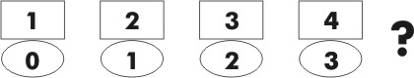

What comes next?

A. 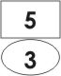 B. 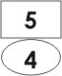

C. 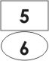 D. 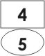

5. See the pattern below.

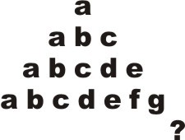

What will be the LAST letter in the next line of the pattern?

A. g

B. h

C. i

D. z

6. Here is a part of a children's rhyme:

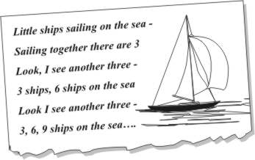

This rhyme can teach you

A. addition by 2's

B. multiplication table of 2

C. multiplication table of 3

D. addition by 6's

7. Mita first bought 33 chocolates for her son Yash's birthday. Later she thought more friends of Yash would come and she bought 15 more chocolates. Yash gave away 40 of the chocolates his mother bought, to his friends. How many chocolates remained?

A. 0

B. 7

C. 8

D. 25

8. Salil had 2 boxes of pencils. Each box had 4 red and 3 blue pencils. The total number of pencils that

Salil had is:

A. 7 + 2

B. 7 🞩 2

C. 12 🞩 2

D. 12 + 2

9. Which of these is true about the two numbers '95' and '495'?

A. 95 is 4 times 495.

B. 95 is 4 less than 495.

C. 495 is 4 times 95.

D. 495 is 400 more than 95.

10. What is 3 times 13?

A. 16

B. 39

C. 133

D. 313

11. A tailor has to put 5 buttons on a shirt. How many buttons will he need for 12 shirts?

A. 12 + 5

B. 12 🞩 5

C. 5 + 5 + 5 + 5 + 5

D. 12 🞩 12 🞩 12 🞩 12 🞩12

12. Shown here are the years in which Maruti started selling different models of cars.

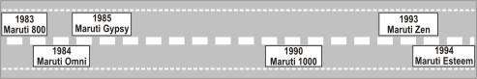

Which car was launched before Maruti 1000 but after Maruti 800?

A. Maruti Zen

B. Maruti Omni

C. Maruti Esteem

D. Maruti 1000